CHARLESTON LAKE 2022 REPORT ON WATER QUALITY

Charleston Lake Association has been sampling water for over 20 years. Again in 2022 summer, forty-two phosphorus samples and water clarity recordings were collected over the period May 25th to October 30th inclusive; six samples from each of seven basins in the lake. The parameters included water clarity (Secchi depth recordings), total phosphorus, calcium, and chloride. This is done in association with the Ministry of Environment Conservation and Parks (MECP) under their Lake Partner Program.

WATER CLARITY RESULTS

During the spring, summer and fall of 2022, Charleston Lake once again experienced excellent water clarity (Average Secchi depth 7.46m); this value is higher than the last 5 year average of 6.51m and closer to the 2009-2013 period when the zebra mussel colonization was at its peak. When compared to the first five years (2000 to 2004 inclusive) of clarity data the improvement is remarkable. The mean water clarity value for the first five years is 4.305 m. The largest part of the improvement in clarity is the result of the zebra mussel colonization of the lake, but that appears to have been stable for a number of years and the results continue to improve. Donaldson Bay had the highest average clarity at 8.48m, ranging to Deep Water (Runnings Bay) at 6.87m average.

Table 1 shows the mean depths for the last 20 years for the whole lake as well as the individual basins Figure 1 provides a graphical representation of the stability in the last 10 years for the whole lake. Water clarity is mostly a representation of water turbidity and algae levels but Secchi disc readings can be impacted by overcast conditions, gusty winds and water surface conditions. The recordings this year were done in mostly sunny weather with light winds. All the readings in the basis are captured in the appendix.

Water clarity has improved so much in recent years that the mean value for the 21-year period of record (6.159 m) places Charleston Lake in the oligotrophic category for the entire time frame, despite the fact that for the first five years of that period (2000 to 2004 inclusive) the water clarity averaged only 4.305 m. Oligotrophic lakes have a water clarity > 5.0 metres.



**FIGURE 1 Charleston Lake Yearly Mean (Whole Lake)**

**Secchi Disc Depth (m) 2000-2022**

TOTAL PHOSPHORUS (TP)

The 2022 total phosphorus from the MOECP Lake Partner Program showed a mean average of 8.93 ug/L compared to the previous 5 test periods (2016-2021) of 9.03 ug/L. These levels are below (better) than the Provincial Water Quality Objective of 10 ug/L, and have been for over 10 years. The period of 2000-2004 had a whole lake mean value of 14.027 ug/L, so the last 10 years have shown a remarkable improvement. A big part of the initial improvement was the result of the zebra mussel colonization of the lake, but that appears to have been stable and/or declining for a number of years and the results continue to improve. The mean values (2022) for the various basins are 7.98 Donaldson Bay, 8.79 Deep Water (Runnings Bay), 8.85 Big Water, 8.92 Eastern Water, 8.95 Webster Bay, 9.48 Eastern Water, 9.56 Goose Island. 20 year results can be seen in Table 2 and Figure 1. All results for 2022 basins can be found in Appendix.

Charleston Lake has reached a new steady-state equilibrium with respect to total phosphorus concentration for the period 2009- 2022 inclusive that clearly places Charleston Lake in the oligotrophic category for this parameter. Lakes in this category are typically clear, dilute and have low phytoplankton densities and rarely experience nuisance algal blooms.



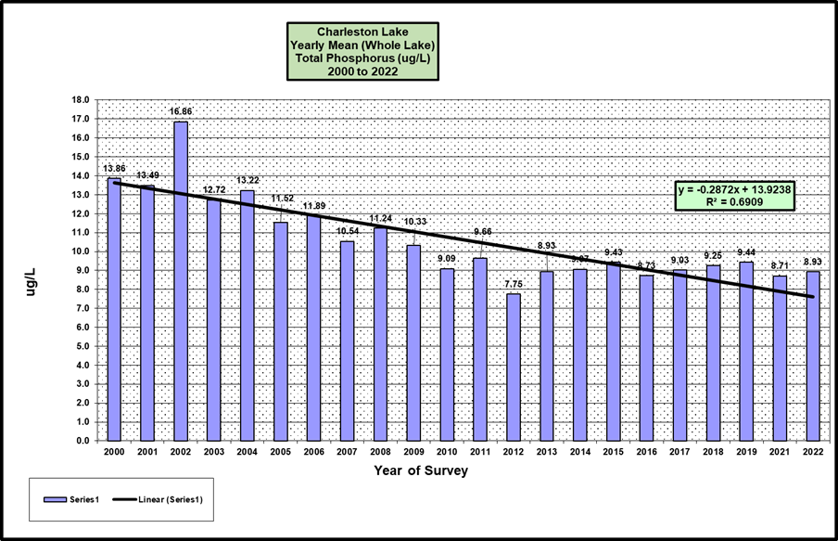

CALCIUM AND CHLORIDE

Mean Calcium (25.35mg/L) and Chloride (8.56) are close to values recorded as far back as 1975 and are not expected to decline as Charleston is not an acid stressed lake.

SUMMARY

We should take pride in the fact that our lake is in good shape.  Through a combination of good luck and good management we have seen Charleston Lake return to near pristine conditions from where it was a generation ago.  We can't take it for granted but we will continue to sample and monitor results and do what we can to make sure it stays this way.

John Willson and Gary Nielsen

APPENDIX

Detailed Results by Date and Basin





